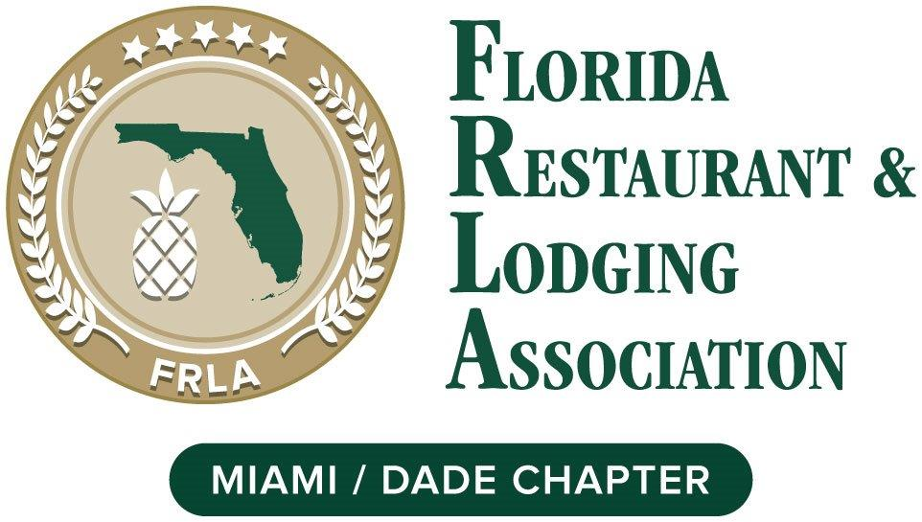

Florida Restaurant & Lodging Association (Miami-Dade Chapter)
Board of Directors Application
Name: Click or tap here to enter text. Title: Click or tap here to enter text.
Company Name: Click or tap here to enter text. Telephone: Click or tap here to enter text.
Street Address: Click or tap here to enter text. City: Click or tap here to enter text. Zip: Click or tap here to enter text.
Email: Click or tap here to enter text.
I am interested in serving on the board because: Click or tap here to enter text.

Please describe the area(s) of expertise/contribution you feel you can make to further the mission of the FRLA: Click or tap here to enter text.
I am able to attend monthly board meetings and support FRLA activities: Click or tap here to enter text.
Area(s) of expertise/contribution you feel you can make: Click or tap here to enter text.
Other volunteer commitments Click or tap here to enter text.

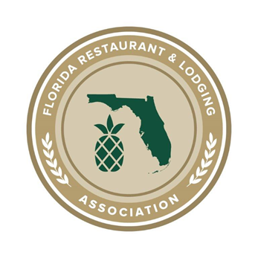
2022 Board of Directors Pledge

I, (Print name here) Click or tap here to enter text. Do hereby pledge to adhere to the policies below as a Board Director with the Florida Restaurant and Lodging Association Miami-Dade Chapter for a one-year term.
☐(check) As a Miami- Dade Chapter Board Director I understand that I am charged with setting and implementing goal responsibilities of this Chapter, and with maintaining a strong relationship with my parent organization, the FLORIDA RESTAURANT & LODGING ASSOCIATION.
☐(check) As a Miami-Dade Chapter Board Director I solemnly pledge to uphold the By Laws of FRLA and my Chapter, to adhere to the FRLA Code of Ethics, and to perform my duties as Chapter Director to the best of my abilities.

☐(check) As a Miami-Dade Chapter Board Director I acknowledge that I am required to attend board and chapter meetings and activities. Board meetings are held every month. Attendance at meetings is paramount to the effectiveness of our board.

☐(check) Board members shall attend at least 70% of Chapter meetings and not miss more than (2) consecutive meetings to remain an active Board Director.
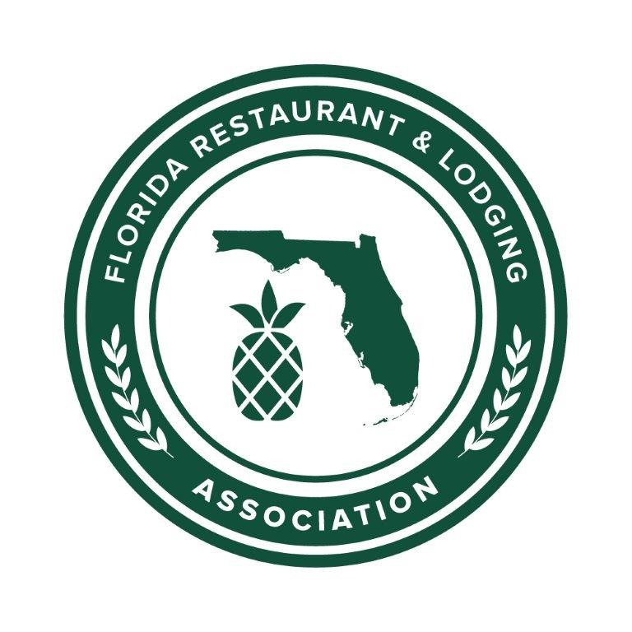
☐(check) As a Miami-Dade Chapter Board Director I acknowledge that I am to actively participate with a Committee.

☐(check) As a Miami-Dade Chapter Board Director, I acknowledge that I am to support chapter special events, activities, promote attendance and help to acquire sponsorship.

☐(check) As a Miami-Dade Chapter Board Director, I agree to promote membership in the FRLA and acknowledge that I am to bring in at least three new members annually.

☐(check) I acknowledge that all Miami-Dade Chapter Correspondence are private and confidential and are not to be shared.

☐(check) As a Miami-Dade Chapter Board Director I acknowledge that I have the opportunity to hold a leadership position with the Association. And network with my peers.

I acknowledge and agree to the pledge herein,
Signed: Date: Click or tap to enter a date.
Print Name: Email: Click or tap here to enter text.

Please return this form to: Lynne M. Hernandez
Executive Director, FRLA Miami-Dade & Monroe
Florida Restaurant & Lodging Association. PO Box 566263, Miami, FL 33256
(305) 710-3962 Lhernandez@frla.org www.frla.org

