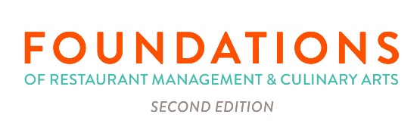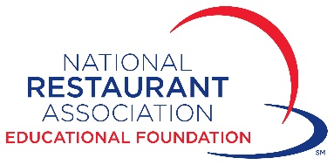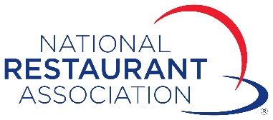

March 2020

Dear ProStart Educator:

Below are additional resources and suggestions on how to keep your ProStart students learning with the 2nd edition of Foundations of Restaurant Management and Culinary Arts while you are away from the classroom. See page two for information on exam administration from now through May 31, 2020.

Textbooks.restaurant.org
We recommend visiting our website: textbooks.restaurant.org. There, instructors and students can find resources such as:
- Chapter Videos/Animations
- Industry Interviews
- Mise en Place
- Resume and Cover Letter Builders
- Information on Global Cuisine

Teacher’s Companion
Another great resource is your Teacher’s Companion, found on the Teacher’s Resources USB or downloaded files. Here you can choose from:
- Discussion Prompts
- Case Study Questions
- Homework Assignments
- Vocabulary
- Tailor Your In-Class Activities to Work at Home
- Differentiated Learning Activities for Each Learning Objective

ExamView Assessment Suite
ExamView can be found on your FRMCA 2/e ExamView USB or downloaded files. Use ExamView to:
- Create custom worksheets and assessments
- Preloaded with question banks for each chapter in each book
- Select the chapter(s), number and type of questions (true/false, multiple choice, short answer, essay) you would like on your worksheet
- Screen grab your worksheets and either upload to your LMS or email to your students for completion.

Student Activity Guide
If your students have access to their print activity guides, you will find a very wide array of cross-curricular activities to choose from:
- Active reader
- Technical Writing
- Culinary Math
- Science
- Multiple Activities for Every Learning Objective in our Textbooks

Exam Administration
In order to assist with examination administration at this time, the Association is relaxing its proctoring requirements for the Foundations of Restaurant Management and Culinary Arts (FRMCA) exam. Until May 31, 2020, you may proctor the exam virtually using Zoom, Skype, Webex, or any other tool that will allow you to monitor students virtually as they complete the exam. You will need to ensure their location conforms to the usual test location standards and have the student show you:
- the location is conducive to exam testing with no distractions, including additional people within the space
- all 4 walls of their testing room
- a view of the surface their computer is on as well as all round and under the surface their computer is on
- a full view of your examinee and then a close up of their ID to confirm identity
- the computer screen so the examinee is not using another web browser or web application during the exam
- that audio is enabled to ensure there are no 3rd parties in the room or inappropriate distractions during the examination

Please note these considerations prior to administering the FRMCA exam virtually:
- This exception is only available until May 31, 2020. After this time period you must resume proctoring FRMCA exams following standard protocols and requirements.
- Some Departments of Education / District School Boards require a proctor to be physically present to administer the exam. This solution may not meet these requirements and it is up to the instructor to determine if this solution is viable for the requirements in your state.
- If you are teaching ServSafe in your classroom, you cannot use this method for the ServSafe Manager Examination due to accreditation standards set by the American National Standards Institute – Conference for Food Protection. The ServSafe Manager Examination must have a physical proctor present.

We hope that these resources and exam considerations will help you complete the school year successfully. Please share if a particular remote learning approach is working well for you and your students, and we can share it with the ProStart community. You can send your best practices to your FRMCA sales rep or to textbooks@restaurant.org.

As always, if we can help in any other way, please reach out. We realize this is not the most ideal of times, but we are all in this together and will make it work the best we can!

Sincerely,

Your Foundations of Restaurant Management and Culinary Arts 2/e sales team (contact information on page three)

Lauren Robin
Senior Sales Representative, Central
Lrobin@restaurant.org

Maggie Braunscheidel
Sales Representative, West
mbraunscheidel@restaurant.org

Liz Rice
Sales Representative, East
Lrice@restaurant.org

Jill Arnett
Channel Vice President, Academic Markets
National Restaurant Association
jarnett@restaurant.org

