IN-PERSON with SOCIAL DISTANCING STUDENTS
HOW DO YOU SAFELY COOK WITH IN-PERSON STUDENTS?
Some instructors are not doing labs for the first 9 weeks. Other instructors are doing demos first before they advance to students cooking. Other instructors do not know how to teach culinary without labs so they will be doing labs. Since masks are required for restaurant workers, one teacher is requiring her students to wear masks whenever they prepare food/work in labs.

TO DO THIS SAFELY, SHOULD ALL LABS BE INDIVIDUAL OR CAN STUDENTS WORK IN GROUPS?
The few people that said they would consider doing labs said it would be individual labs. At least one county is requiring a seating chart for each class. That way they can contract trace a positive student. If you had the students work in groups, it would make the contract tracing more difficult.

HOW ARE YOU SETTING UP YOUR CLASSROOM TO ALLOW FOR SOCIAL DISTANCING? WHAT IF YOU HAVE TABLES AND NOT DESK?
One instructor has 12 in by 12 in square tiles on the floor. She just used the tiles to separate her desk. There does not seem to be a clear answer for how to socially distance when you have stainless steel tables instead of desk.

CAN STUDENTS EAT THE FOOD THEY PREPARE IN CLASS?
At least one county is only allowing students to eat in the cafeteria, so this is not possible. Another county will have the students eat breakfast in their first period class so it might be possible for students to eat in the classroom.

CAN YOU PREPARE FOOD TO SELL TO STAFF?
One county is not allowing it while another is. Discuss the situation with your administration. If you are concerned about whether the teachers will even buy the food, send out a survey prior to incurring any cost. If you do sell food, you will probably need to consider your packaging. Have some senior students come in to work through set up and think through packaging options.

NOTE – One instructor mentioned she does not currently have virtual students. However, she is confident that at some point some students will be required to quarantine. Therefore, she is going to go ahead and record demos to use with the quarantining students.

NOTE - Spoke with Chef Alex from Valencia College. He said they are having their in-person students wear disposable aprons and use plastic clothes as well as wear mask. Then everything is thrown away when they leave the lab. NOTHING comes into the kitchen with the students. They are also reducing the number of students in the kitchen, if possible, to allow for plenty of spacing. If in-person students are not comfortable preparing a lab, then allow them to participate in the lab in the same fashion as the virtual students.

ONLINE ONLY STUDENTS
ARE SCHOOLS ALLOWING LABS AT HOME FOR A GRADE? HOW DO YOU HANDLE COOKING VS NOT COOKING?
Most attendees are not going to allow the virtual students to conduct required cooking labs. You could perhaps give them optional labs to enhance what you discussed. For example, if you are demoing a roux, you can give the students an optional lab to conduct on their own at home to better understand the process. Be sure to include that adult supervision is required for any at home labs.

IDEAS ON ONLINE DELIVERY OF CULINARY PRACTIES. HOW WILL YOU TEACH PRACTICALS?
You can do lessons on topics such as equipment, cutting boards, etc. You can then do a quiz on each topic such as which colored cutting board is used for chicken. Studioark/Studioart was recommended. (We were unable to find it online, but I am sure some of you are familiar with the program.)

WHAT ARE THE BEST METHODS FOR TEACHING KNIFE SKILLS?
One instructor recommended having pictures of different cuts. Then have the students match the cuts to the name, description, and measurements. It can be more difficult depending on the level. For example, first year students may only match the picture and the name.

WHAT EQUIPMENT IS NEEDED TO RECORD A DEMO AT HOME/SCHOOL?
A phone seems to work best to record demos. It was recommended that you do not attempt to have two as it is hard to manage both. Either way you need one other person to record while you demo. From experience, do not attempt to use the stove. Instead use a butane burner on the island or countertop. Have your mise en place set up to the side. Make sure you have it on speaker view setting or have your group gallery minimized when you are recording.

IF THE STUDENTS CAN COOK, WHAT ARE SOME IDEAS FOR LABS?
Examples shared were as simple as having them make a sandwich. Even if your district does not allow cooking, this option would work. Students can submit videos of themselves washing the dishes or working in a garden. Students are eating so have them submit a video/picture of them preparing their lunch. They can include a picture of the finished item along with the recipe they used. Students can prepare a safety and sanitation video. For extra credit, the parents can explain in writing what the student did or something the parents learned from the student’s video. One instructor did a demo on fried rice. Then had the students submit video/pictures of the fried rice they created at home.
These videos can be a class requirement or awarded as extra credit so that they are not required.

ALTERNATIVE ASSIGNMENTS FOR THOSE ONLINE STUDENTS WHO CAN NOT COOKE. HOW DO YOU ASSES A HANDS-ON ACTIVITY IF ONLINE STUDENTS DO NOT HAVE ACCESS TO MATERIALS OR COOKING EQUIPMENT?
Most attendees said they would be using videos with questions afterwards to assess the students. Several instructors plan to do ServSafe for the first nine weeks and focus on book learning.

HOW ARE OTHER SCHOOLS HANDLING LIABILITY FOR THOSE TEACHERS HOPING TO HAVE VIRTUAL STUDENTS COOK AT HOME?
One county is not allowing virtual students to cook since they are not being supervised by the instructor. Another county believes the liability lies with the homeowner since the student is not on school property. Even within this county, one administrator told the instructor she cannot have the students cook at home.

BESIDES FLIPGRID, WHAT OPTIONS ARE AVAIALBLE FOR STUDENTS?
Flipgrid allows students to submit videos of themselves (maybe a time limit such as one minute). You can create groups, i.e., your second period, and everyone can see the videos created. You can then grade the video as you would a demo.
Below are two Flipgrid links that Suzanne O’Neil shared with the group. She intentionally did not focus on the professionalism of the videos as she wanted her students to feel comfortable making their own.
https://flipgrid.com/s/6b862faf2518
https://flipgrid.com/s/a3dae313fe8f

Marco Polo is another option. It allows you to pause the video and comment. Perhaps if a student is doing something incorrectly. The videos do not disappear as they would on a format such as SnapChat.
WHAT ARE GOOD IDEAS FOR KEEPING STUDENTS ENGAGED ONLINE?
www.SuperCook.com is a website that allows you to enter the items in your pantry. Then it gives you a list of recipes using those items. In the spring, one instructor used it for quarantine cooking competitions. Another resource is www.Edpuzzle.com that an instructor used in the spring.

CAN YOU SHUT DOWN YOUR CHAT FUNCTION ON MICROSOFT TEAMS OR OTHER FORMATS?
One instructor has had virtual students for over a week and three students have already been written up for inappropriate comments in chat.
Before you begin with virtual students, know how to deal with inappropriate conversations.

WHERE ARE OTHER RESOURCES FOR INSTRUCTORS?
There are a lot of FaceBook ProStart and ServSafe pages. They all offer a lot of information and sharing. To find groups, search using key words like ProStart, ServSafe, FCS, etc.
There are a lot of CIA videos on YouTube.

IN-PERSON AND ONLINE STUDENTS
TO MAKE LIFE EASIER, SHOULD I PLAN FOR ONLINE AND TEACH FROM THERE EVEN WITH MY IN-PERSON KIDS?
One instructor recommended you record once for your online students and then post it. That way the students can view the video at any time during the day. If you want, you could use the same video for your in-person students but would have to address the issue of keeping their attention while they sit in class and watch a video. Another instructor said it was required the students log in during their specific assigned time so posting a video for the virtual students to watch whenever they wanted, would not work.

NOTE – I spoke with Chef Cynthia from UCF. They will have in-person students and virtual students at the same time. Their chef instructor will be teaching the lab as usual. There will be an assistant that moderates zoom. Do you have a TA or stellar student that could handle the moderation duties? Include polls for the virtual students throughout the class time to ensure they are paying attention. Have two devices logged into the virtual class. That way if one goes down, the moderator simply picks up the other one. The recommendation is that at least one of the devices should be a cell phone. The moderator can take the cell phone around the lab. They can move around the class and zoom in on the work students are doing. It makes the class more interactive and hopefully keeps the student’s attention. They recommended you find students, perhaps your own, to practice with before you have students in class.

ProStart Details
Food Safe Chemicals for Cleaning
Below is information on food safe chemicals to be used for cleaning. The information below is from page 10.4 of the ServSafe book.
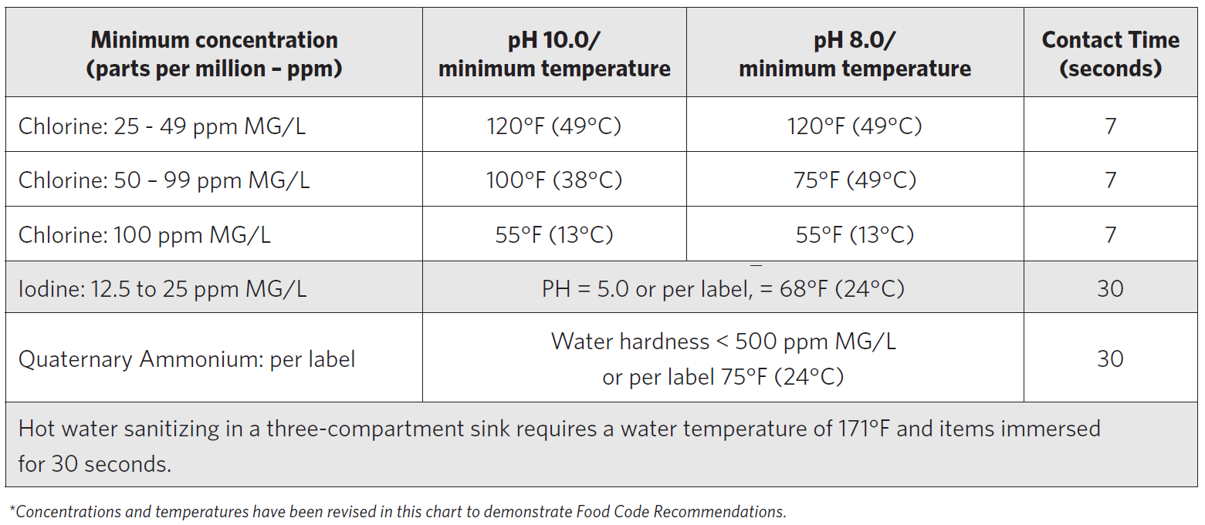

Hand Sanitizer
Hand sanitizer is not assessed as food safe or not. Hand sanitizer of 60% alcohol or greater is effective against Covid, and when used according to the label instructions is generally safe in a food preparation environment. Sanitizer of that strength when abused is also potentially toxic. Sanitizer is not an acceptable substitute for frequent and proper handwashing. Additional resources are below.

FDA article on hand sanitizer in general:
https://www.fda.gov/consumers/consumer-updates/safely-using-hand-sanitizer

FDA PDF on food safety during Covid:
https://www.fda.gov/media/136811/download

University of Wisconsin (very solid extension and food safety resource):
https://fyi.extension.wisc.edu/safefood/2020/04/17/food-safety-in-the-time-of-covid-19-say-no-to-hand-sanitizer-diy/

Online ServSafe Prices
The ServSafe materials will not be free this year. The price for the eBook only is $48.92. (The course book is supposed to be available in the middle of August.) The price for the book plus the online exam voucher will be $81.92. The price for remote proctoring alone is $63. If you want all three, eBook, online voucher and proctoring, the price is $144.92 per student. If you are interested in ordering, contact Liz Rice with the National Restaurant Association. She can be reached at LRice@restaurant.org.

ProStart Prices
https://textbooks.restaurant.org/
If you are interested in an individual eBook tutorial, please contact Liz Rice at LRice@restaurant.org.

Remote Proctoring
DOE has not announced remote proctoring plans for the 2020-2021 school year. However, they have announced that through October students may earn industry certifications for the 2019-2020 school year. The remote certifications and processes that were approved in the spring are viable through October for the 2019-2020 school year.

Online Resources
This page includes video/animation for each chapter of the Foundations curriculum.
www.frla.org/online-resources-for-prostart-servsafe/

Foundations Scantron Exchange
You may exchange Foundations scantrons for online codes until September.
Email Liz Rice at LRice@restaurant.org for instructions.

NATIONAL REGISTRY
Students can earn the CPFM using the National Registry program as well as the ServSafe program. For more information on the National Registry program, go to their website at www.nrfsp.com.

