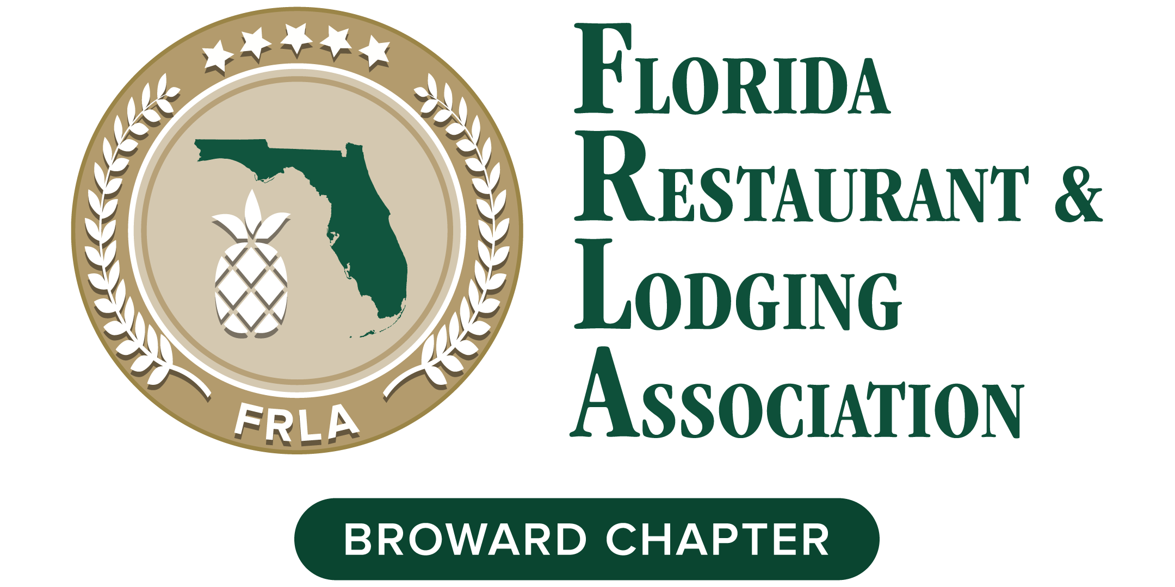

LOVE is in the FRL-Air
Bingo Mingle with a purpose!
A Hospitality & Education FUNdraiser!
Thursday FEB 18, 2021 7:00 – 9:00 pm

FRLA Broward Chapter is pleased to announce our Valentine Networking FUNdraiser.
This virtual event gives you the perfect opportunity to mix and mingle with members in a fun and entertaining time. For those looking for a little extra spotlight, we offer the following sponsorship.

$10 Bingo Cards. We will play (5) games or more time permitting. You can purchase unlimited number cards and play with the same card(s) for all games.

$25 Ball Sponsor. (up to 75 available spots) Your Company Tagline will be read each time your ball number has been picked. Special announcement will be made if your number has not been called out.

$250 Sponsorship. (Only 5 available) You get a 30 sec timeslot in between games to promote your business. You may have a slide, video, or simply do your elevator speech. You will also receive a dedicated promotional Eblast to appx 1200 local members and partners in the region.
COMPANY NAME: _____________________________
(as you would like to be listed in promotional materials)
CONTACT NAME: _____________________________
ADDRESS: _________________________________
CITY/STATE/ZIP: _____________________________
PHONE: __________________________________
EMAIL: __________________________________

Purchase cards & balls: Paypal to BrowardBingoMingle@gmail.com
Email sponsorship form to: Rmahboubi@frla.org
For information contact Rozeta Mahboubi 954.270.5814

