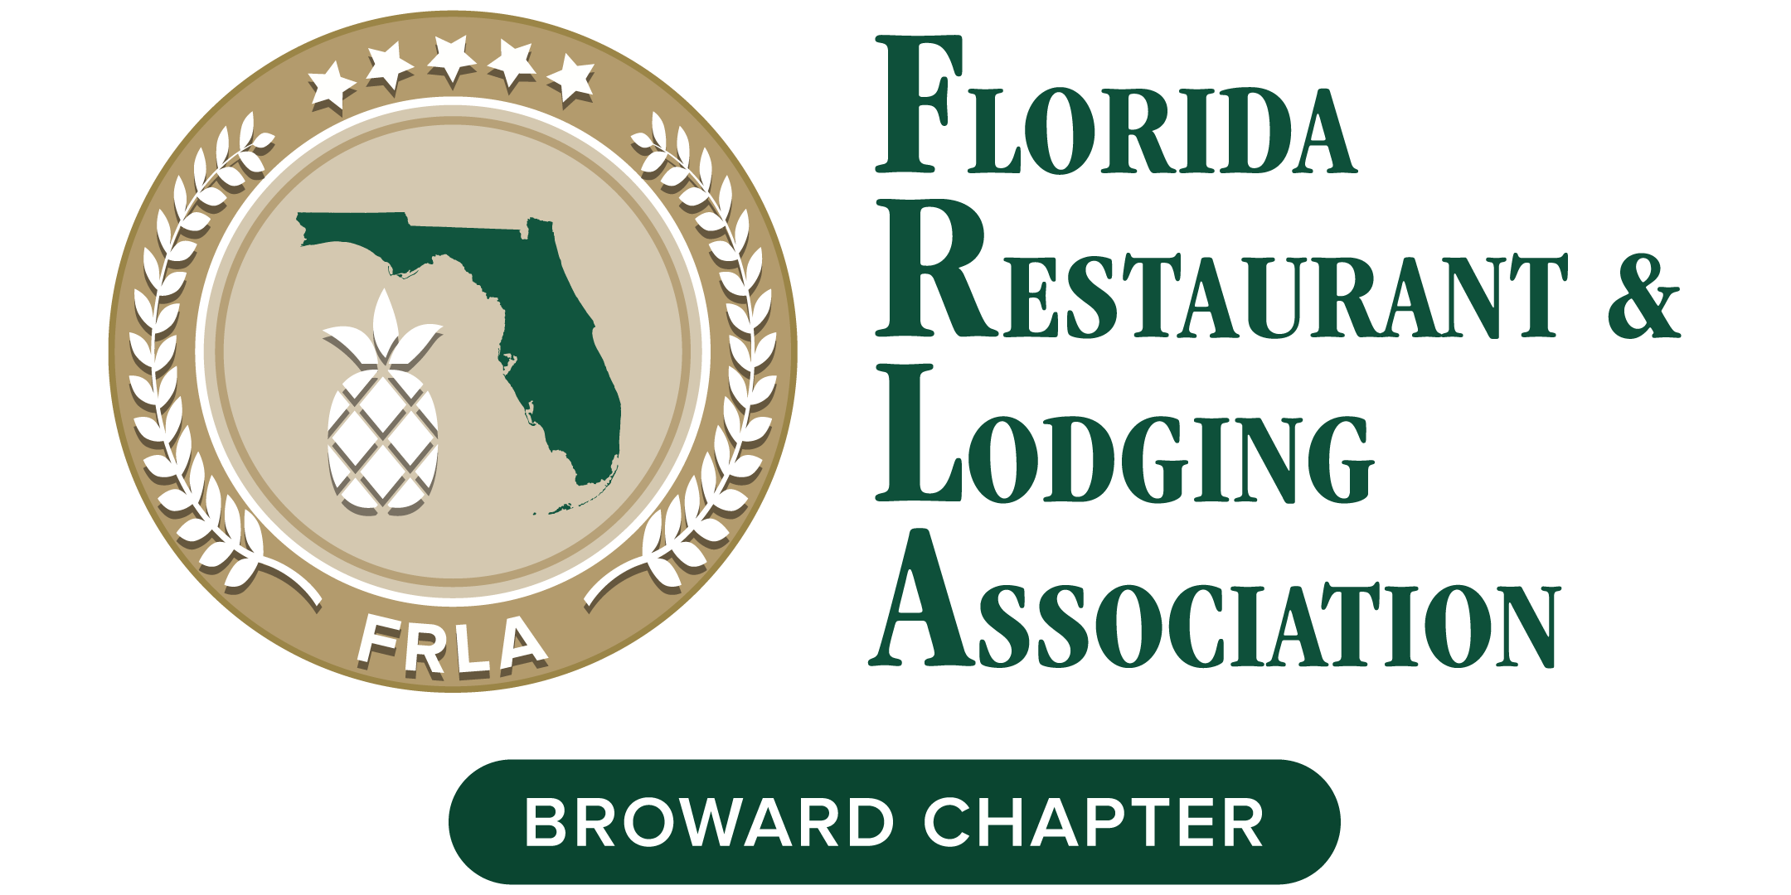

2021 Reverse Tradeshow
Hotel / Restaurant Form

Join us for the return of Broward Chapter Reverse Tradeshow, a Hospitality Business Exchange and Networking Expo featuring National Industry Expert Speakers TBA current hospitality crisis and solutions including procurement and labor challenges.

Support your FRLA Broward Chapter and meet local allied members and suppliers with unique products and services you need. Space is limited so RSVP ASAP!
HOTEL or RESTAURANT NAME: _______________________
(as you would like to be listed in promotional materials)
- NAME / TITLE: __________________________
EMAIL / CELL: _____________________________
2. NAME / TITLE: __________________________
EMAIL / CELL: _____________________________
3. NAME / TITLE: ___________________________
EMAIL / CELL: ______________________________

Please contact with cc payments
Rmahboubi@frla.org (954) 270-5814

