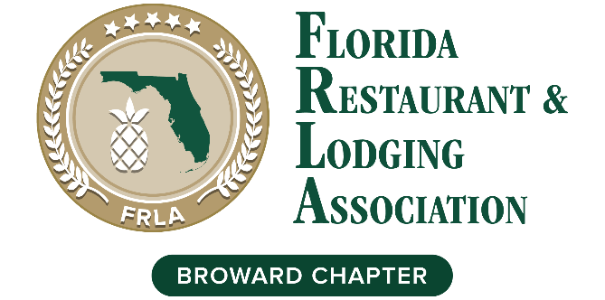

Reverse Tradeshow
A Hospitality Business Exchange & Networking Expo
Monday Sept 13, 2021, 1:30 – 6:30 pm

Join us for Broward Chapter’s Reverse Tradeshow, a hospitality business exchange and networking Expo to support the hospitality community. Meet hotel and restaurant leaders and executive decision makers who want to do business with FRLA Allied members. Our goal is to have a minimum of (30) hotel and restaurant people participate in this event.

As a sponsor, you can elevate your brand visibility and promote your business while supporting the FRLA Broward Chapter initiatives for the hospitality industry, including scholarships, events, lobbying efforts, etc. Event Overview & Registration fees:

    - 1:00 – Registration
    - 1:30 – Welcome, program overview, Intro of Sponsors,
      - Guest Speakers: National Industry Experts TBA
    - 2:30 – 5:00 – Reverse tradeshow – 3 minutes per vendor
    - 5:00 – 6:30 – Happy Hour (registration includes one drink / appetizer)

- Allied Members only $95 per person
- Restaurants / Hotels only $20 per person
- Who should attend from the Hotels / Restaurants: Owners and General Managers, Director of Operations, Purchasing or Procurement and Director of Marketing, Sales & Catering

PRESENTING SPONSOR $2,000
- Company name/logo included in event title, invitations, promotions, and recognition during event
- (5) minute screen time including video or presentation plus (8) Admission Tickets to event

GOLD SPONSORS $1,500
- Company name/logo included on invitation & promotions and recognition during event
- A company slide with a short script during the event plus (6) Admission Tickets to event

SILVER SPONSOR S $1,000
- Company name/logo included on eblasts and recognition during event plus (4) Admission Tickets to event

BRONZE SPONSORS $500
- Company name/logo on eblasts and during event plus (2) Admission Tickets to event

