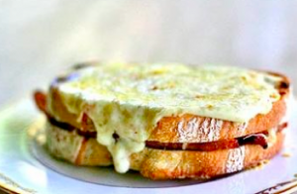
The Croque Monsieur, or “Crispy Mister,” first appeared on Parisian café menus circa 1910. The original Croque Monsieur was simply a hot ham and Gruyere cheese sandwich, fried in butter. Some believe it was accidentally created when French workers left their lunch pails by a hot radiator and came back later to discover the cheese in their sandwiches had melted. That’s an entirely conceivable story, but an unacknowledged cook somewhere had the culinary ingenuity to take that bland hot sandwich and sauté it in butter until it turned crisp and golden brown. That move is what truly deserved the fame and honor for this scrumptiously addictive sandwich. Found all over France today, the Croque Monsieur - casually referred to as a Croque - has as many recipes and variations as it has cooks. The crunchy sandwich is served as an appetizer, snack, or casual meal.
Croque Monsieur

INGREDIENTS
2 tablespoons butter
2 tablespoons all purpose flour
1 cup whole milk
Pinch ground nutmeg
1 bay leaf
8 slices firm white sandwich bread
8 ounces thinly sliced Black Forest ham
4 ounces sliced Gruyère cheese (8 slices)
1 tablespoon melted butter
1/4 cup grated Gruyère cheese
2 teaspoons chopped fresh chives

METHOD:
- Melt 2 tablespoons butter in small saucepan over medium heat. Add flour and stir 1 minute. Gradually whisk in milk. Add nutmeg and bay leaf. Increase heat to medium-high and boil until sauce thickens, whisking constantly, about 2 minutes. Season with salt and pepper.

- Preheat broiler. Place 2 bread slices on work surface. Top each with half of ham and sliced Gruyère. Top with remaining bread.

- Heat heavy large skillet over low heat. Brush sandwiches with 1 tablespoon melted butter. Add to skillet and cook until deep golden brown, about 2 minutes per side.

- Transfer to small baking sheet. Spoon sauce, then grated cheese over sandwiches. Broil until cheese begins to brown, about 2 minutes.

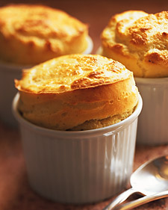
According to the food historians, modern soufflés (both sweet and savory) were a product of 18th century French cuisine. The method is related to that of a meringue. A French word which literally means "puffed up," is a culinary term in both French and English (and used in many other languages) for a light, frothy dish, just stiff enough to hold its shape, and which may be savory or sweet, hot or cold. The basic hot soufflé has as its starting point a roux--a cooked mixture of flour and butter...This type of soufflé was a French invention of the late 18th century. Beau Villiers was making soufflés possibly as early as 1782 (though he did not publish his L'Art du cusinier until 1814). Recipes for various kinds appear in Louis Ude's The French Cook of 1813, a work which promises a "new method of giving good and extremely cheap fashionable fare at soirees. Later, in 1841, Careme's Patissier Royal Parisien goes into great detail on the technique of making soufflés, from which it was made clear that cooks had been having much trouble with soufflés collapsing. The dish acquired a reputation for difficulty and proneness to accidents which it does not really deserve. One of the most common misconceptions as to why a soufflé falls is a loud noise will cause it to deflate. It doesn’t; as a matter of fact, this culinary old wives’ tale is not supported by science. The rise and (and the inevitable fall) of every soufflé is a direct result of temperature. Heat expands the air in the egg whites; coolness deflates it.
Gruyère Soufflé Yield 6-8, 4 oz soufflés
INGREDIENTS:
5 ounces A.P Flour
4 ounces Butter
¼ ounce Sugar
2.5 cups Milk
8 ea Eggs, separated
4 ounces Gruyère Cheese, grated
4 ounces Parmesan, grated
½ ounce parsley, chopped
1/2 Tablespoon salt

METHOD:

- Mix flour and butter together into beurre manie

- Bring milk and salt to a boil; add beurre manie to boiling milk as in pate choux; cook out for 5 minutes

- Put choux in kitchen aid with paddle and slowly add yolks; add grated cheeses to choux mixture (reserve some parm for dusting the soufflé cups with)

- Whip whites with sugar to stiff peaks; gently fold whites in batches to choux

- Butter moulds and dust with reserved parm; fill 2/3 with batter

- Bake in convection oven at 350◦F for 10-15 minutes

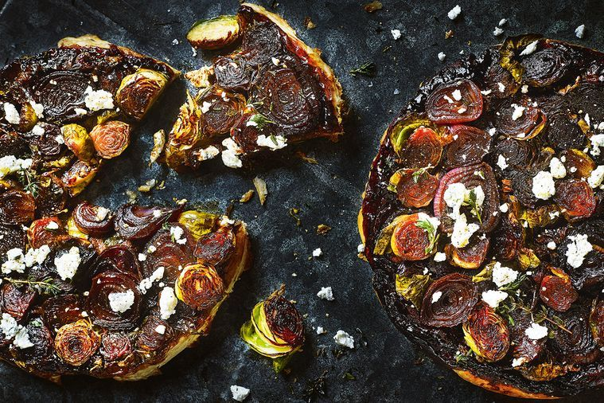

Caramelized sprout and red onion tarte tatin
Ingredients:
- 2 sheets all-butter puff pastry, thawed
- AP flour, to dust
- 1 egg, lightly beaten
- 1TBS unsalted butter
- 3 small red onions, sliced into thick rounds
- 1LB brussels sprouts, halved
- 1/4 bunch thyme, leaves picked, plus extra sprigs to serve
- 1 TBS raw caster sugar
- 3 TBS balsamic vinegar
- 1.5oz goat’s cheese, crumbled
Method:
Preheat the oven to 375 degrees

2.
To prepare the pastry, place 1 sheet on a clean work surface lightly dusted with flour. Brush with beaten egg, then place another sheet of pastry directly on top. Smooth with a rolling pin, then roll out to a 35cm square. Cut a 28cm-diameter circle from the square. Transfer to a baking tray lined with baking paper and chill until ready to use.
3.
Heat 9in non-stick ovenproof frypans over medium heat. Add the butter and swirl to melt. Divide onion and sprouts between pans and arrange in a single layer. Cook, without stirring, for 5 minutes or until beginning to caramelize. Sprinkle with thyme leaves.
4.
Combine sugar and vinegar, then add to pan. Cook for 5 minutes or until reduced and glossy.
5.
Remove pans from heat and top with a prepared pastry round. Tuck in edges to seal and brush with remaining beaten egg. Transfer to oven and bake, swapping shelves halfway, for 20 minutes or until the pastry is golden and crisp.
6.
Carefully turn out tarts onto serving boards or plates, scatter with goat’s cheese and sprinkle with extra thyme sprigs. Serve tarts immediately.

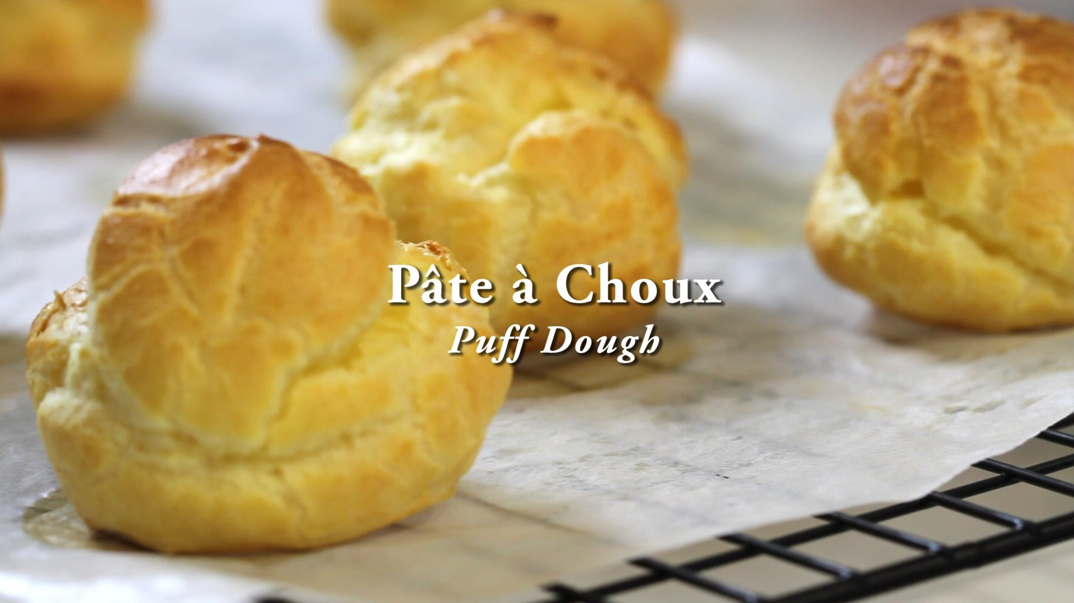
Choux pastry, or pâte à choux (pronounced: [pɑt a ʃu]), is a light pastry dough used to make profiteroles, croquembouches, éclairs, French crullers, beignets, St. Honoré cake, quenelles, Parisian gnocchi, dumplings,gougères, chouquettes and craquelins. It contains butter, water, flour and eggs. Instead of a raising agent, it employs high moisture content to create steam during cooking to puff the pastry. The pastry is used in many European and European-derived cuisines.
Choux pastry is usually baked but for beignets it is fried. In Spain and Latin America, churros are made of fried choux pastry, sugared and dipped in a thick hot chocolate for breakfast. In Austrian cuisine, it is also boiled to make Marillenknödel, a sweet apricot dumpling, in that case it does not puff, but remains relatively dense. They are sometimes filled with cream and used to make cream puffs or éclairs.
Chouquettes, named for the diminutive of "choux," are small, round, hollow choux pastry covered with large-grain sugar. Craquelins are covered in a "crackly" sugar topping - and often filled with pastry cream, much like eclairs.
Pate a Choux (For Cream Puffs)

8 oz. water
¾ tsp. salt
4 oz. unsalted butter
5 oz. flour
5 Eggs

- In a medium saucepan, combine 1 cup water, butter, and salt; bring to a boil over medium-high heat. Reduce heat to low, and sift in flour, stirring vigorously until dough come away from the sides of the pan..
- Transfer flour mixture to bowl of an electric mixer fitted with a paddle attachment. On medium speed, add eggs, 1 at a time, beating until incorporated after each addition. Continue until dough is shiny, firm and pulls away from the sides in thick strands.
- Put workable amount in a pastry bag with a large plain tip. Pipe out onto sheet pans in even rounds. (Chef will demonstrate for size)
- Bake immediately at 400 degrees for 15 minutes. Reduce heat to 350 and bake until dry and crisp (about 15 minutes more).
- Cool completely, fill as desired.

Pastry Cream

2 cups Milk
1 TBS Vanilla Extract
4 oz. Sugar
5 Egg Yolks
1.25 oz. Cornstarch
1 oz. Unsalted Butter

- Bring milk, and half of the sugar to a boil in saucepan.
- Whisk egg yolks in separate bowl with cornstarch and remaining sugar.
- Temper mixture with one quarter of hot liquid, return all liquid to pan to cook. Whisk vigorously until cream boils and thickens. Allow to boil two minutes and stir constantly.
- Remove from pan into clean bowl, fold in vanilla and butter.
- Cover and place on ice bath.

Cream Puff Assembly:
Poke small hole in bottom of shell and fill with pastry cream. Keep refrigerated until service.

