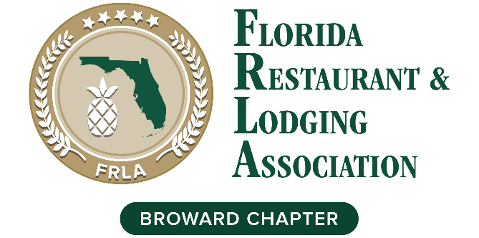

Reverse Hotel & Restaurant Showcase
Connect 1-on-1

A Hospitality Business Exchange & Networking Expo
Monday August 29, 2022, 1:30 – 6:30 pm

Join us again for FRLA Broward 2nd Annual Reverse “Connect 1-on-1” Hotel & Restaurant Showcase, a hospitality business exchange and networking Expo to support the hospitality community. Hotels and restaurants will benefit from meeting companies with valuable products and services. FRLA Allied members will meet hotel and restaurant leaders and executive decision makers who want to do business with them. Our goal is to have a minimum of (30) hotel and restaurant people participate in this event, which was accomplished last year. Elevate your brand visibility and promote your business while supporting the FRLA Broward Chapter initiatives for the hospitality industry, including scholarships, events, and lobbying efforts.
Resister Here: https://2ndAnnualShowcase.eventbrite.com

    - 1:00 – Registration
    - 1:30 – Welcome, program overview, Intro of Sponsors,
      - Keynote Speaker TBA
    - 2:30 – 5:00 – Reverse tradeshow – 3 minutes per vendor
    - 5:00 – 6:30 – Happy Hour (registration includes one drink / appetizer)

- Allied Members only $150 per person
- Restaurants / Hotels only $40 per person
- Who should attend from the Hotels / Restaurants: Owners and General Managers, Director of Operations, Purchasing or Procurement and Director of Marketing, Sales & Catering

PRESENTING SPONSOR $5,000
- Company name/logo included in event title, invitations, promotions, and recognition during event
- (5) minute screen time including video or presentation plus (8) Admission Tickets to event

GOLD SPONSORS $2,500
- Company name/logo included on invitation & promotions and recognition during event
- A company slide with a short script during the event plus (6) Admission Tickets to event

SILVER SPONSOR S $1,000
- Company name/logo included on eblasts and recognition during event plus (4) Admission Tickets to event

BRONZE SPONSORS $500
- Company name/logo on eblasts and during event plus (2) Admission Tickets to event

To become a member or a sponsor contact
Rmahboubi@frla.org (954) 270-5814

