What is a FoodPrint?
Whether it’s a salad, a hamburger or your morning egg sandwich, your meal has an impact on the environment and on the welfare of animals, food/farm workers and on public health.
Your “foodprint” is the result of everything it takes to get your food from the farm to your plate. Many of those processes are invisible to consumers.
Industrial food production — including animal products like beef, pork, chicken and eggs and also crops — takes a tremendous toll on our soil, air and water, as well as on the workers and the surrounding communities.
Learn more about what a foodprint is and why you should care about yours here and in the video below.
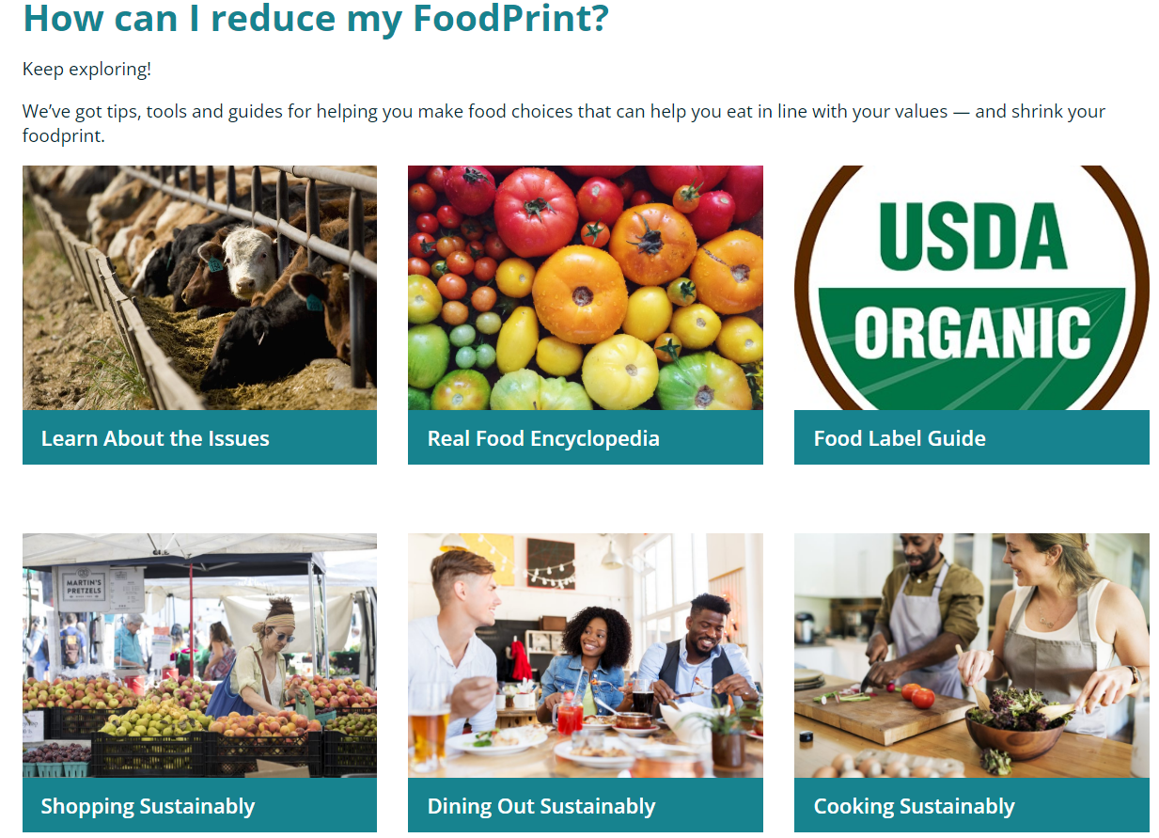
Activity Directions
https://foodprint.org/what-is-foodprint/ Click “Find Out Your Foodprint” https://foodprint.org/quiz

