……………………………………………………

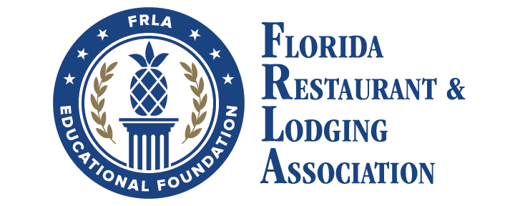

19th Annual

**Florida HTM**

Competition

March 6-7, 2023

19th Annual Florida HTM Competition

**AGENDA**

**MARCH 5 SUNDAY**

6:30 PM – 9:00 PM **SALUTE TO EXCELLENCE AWARDS DINNER**

Attire: SUNDAY BEST

GRAND BALLROOM, ROSEN PLAZA HOTEL

YOUR NAME BADGES ARE YOUR TICKETS!

**MARCH 6 MONDAY**

6:30 AM – 10:30 AM **Breakfast buffet hours** (Café Matisse vouchers provided)

morning Attire: casual, school-appropriate

afternoon attire: business/business casual

9:00 AM – 9:45 AM **Night Audit** in Ballroom A

10:00 am – 12:00 PM **Hospitality Project Preparation** in ballroom a

12:00 PM – 1:00 PM **Lunch** (Café Matisse vouchers provided)

1:00 PM – 3:30 PM **Food & Beverage Case Study**

ATTIRE: BUSINESS ATTIRE IS EXPECTED FOR ENTIRE DAY

Students PREPARE case study in Salon 11

Students PRESENT case study in Salon 12

1:00 PM Colonial High School

1:15 PM Horizon High School

1:30 PM Miami Sunset High School

1:45 PM Oak Ridge High School

2:00 PM Olympia High School

2:15 PM Robert Morgan Educational Ctr

2:30 PM OTC South Campus

2:45 PM Osceola High School

3:00 PM Stoneman Douglas High School

3:15 PM Windermere High School

1:00 PM – 3:45 PM **Guest Services Case Study**

Students PREPARE case study in Salon 9

Students PRESENT case study in Salon 10

1:00 PM Windermere High School

1:15 PM OTC South Campus

1:30 PM Stoneman Douglas High School

1:45 PM Osceola High School

2:00 PM Colonial High School

2:15 PM Horizon High School

2:30 PM Miami Sunset High School

2:45 PM Oak Ridge High School

3:00 PM Olympia High School

3:15 PM Robert Morgan Educational Ctr

1:00 PM – 4:30 PM **Hospitality Project Presentation** in Salon 5

1:00 PM Osceola High School

1:20 PM Robert Morgan Educational Ctr

1:40 PM Olympia High School

2:00 PM OTC South Campus

2:20 PM Stoneman Douglas High School

2:40 PM Windermere High School

3:00 PM Colonial High School

3:20 PM Horizon High School

3:40 PM Miami Sunset High School

4:00 PM Oak Ridge High School

4:00 PM **Food & Beverage Case Study Feedback** in Salon 12

4:00 PM Oak Ridge High School

4:05 PM Stoneman Douglas High School

4:10 PM Osceola High School

4:15 PM OTC South Campus

4:20 PM Robert Morgan Educational Ctr

4:25 PM Olympia High School

4:30 PM Windemere High School

4:35 PM Miami Sunset High School

4:40 PM Horizon High School

4:45 PM Colonial High School

4:00 PM **Guest Services Case Study Feedback** in Salon 10

4:00 PM Robert Morgan Educational Ctr

4:05 PM Olympia High School

4:10 PM Oak Ridge High School

4:15 PM Windemere High School

4:20 PM Horizon High School

4:25 PM Colonial High School

4:30 PM Osceola High School

4:35 PM Stoneman Douglas High School

4:40 PM OTC South Campus

4:45 PM Miami Sunset High School

4:30 PM **Hospitality Project Feedback** in Salon 5

4:30 PM Oak Ridge High School

4:35 PM Robert Morgan Educational Ctr

4:40 PM Horizon High School

4:45 PM Colonial High School

4:50 PM Windermere High School

4:55 PM Stoneman Douglas High School

5:00 PM OTC South Campus

5:05 PM Olympia High School

5:10 PM Miami Sunset High School

5:15 PM Osceola High School

6:00 PM – 7:00 PM **Group Dinner** in Salon 3-4

**MARCH 7 TUESDAY**

6:30 – 10:30 AM **Breakfast Buffet Hours** (Café Matisse vouchers provided)

9:00 AM – 11:30 AM **Knowledge Bowl Competition** in Ballroom A

ATTIRE: BUSINESS/business CASUAL

12:00 PM – 1:30 PM **Awards Luncheon** in 3NINE Club

