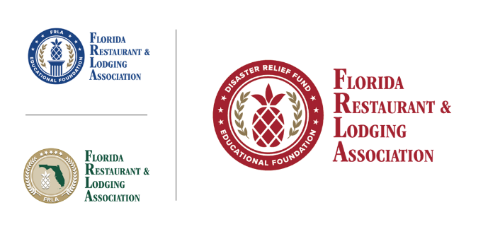
EMPLOYEE INFORMATION

The FRLA Disaster Relief Fund is an initiative of the Florida Restaurant & Lodging Association Educational Foundation. This initiative strives to provide economic relief to Florida’s independent restaurants, independent lodging establishments and employees of these organizations who are financially needy or distressed from the impact of Hurricane Ian.
In order for you and your employer to be considered for funding, each selected employee should fill out the information below and return it to your employer, along with a copy of a voided check.

EMPLOYEE INFORMATION
First Name
Last Name
Home Address
Home City, State and Zip Code:
Email Address
Cell Phone Number

ACH INFORMATION REQUIRED
Bank Account Number
Bank Routing Number

RESTAURANT/HOTEL INFORMATION
Restaurant/Hotel Name
Restaurant/Hotel Owner Name
Dates of Employment
I, the above named employee, of the above-named restaurant or lodging establishment, do hereby agree to the following restricted usage of funds provided by the FRLA Disaster Relief Fund to benefit the Business and its employees. Funds will only be used to accomplish one or all the four concurrent goals. Please check all that applies to how the funds will be dispensed.
Assistance with rent, mortgage payments, or car loan payments. (Required documentation includes but is not limited to a lease agreement for rent or car loan, mortgage statement, or a late notice for rent, mortgage, or car payments)

Assistance with school tuition and higher education costs to permit a child to attend school. (Required documentation includes but is not limited to receipts or registrar from school with expenses)

Reasonable and necessary expenses incurred for the repair or rehabilitation of a personal residence (rented or owned) (Required documentation includes but is not limited to quotes, invoices or statements of repairs made including expenses)

Reasonable and necessary expenses incurred for the repair or replacement of the contents of a personal residence due to Hurricane Ian. (Required documentation includes but is not limited to quotes, invoices or statements of repairs made including expenses)

Required narrative of employee financial needs due to Hurricane Ian and how the disaster relief funds will be used. This is critical to assessing the needs of each employee.

I, the Employee, acknowledge that I am in financial need due to the impact of Hurricane Ian. Recipients should be prepared to provide proof of how the funds were distributed, should the IRS request it.
I agree

Employee, by typing your name below you attest all above to be true and accurate.

To complete your information, return a voided check, along with this form to your Employer.

