**Distinctive Brunch Staples**

***Black Pepper Biscuits with Chorizo Gravy***

***Mini Cheesy Grits Souffle***

***Ultimate Avocado Toast***

***Mushroom and Leek Shirred Eggs with Truffled Mornay Sauce***

**Black Pepper Buttermilk Biscuits with Chorizo Gravy**

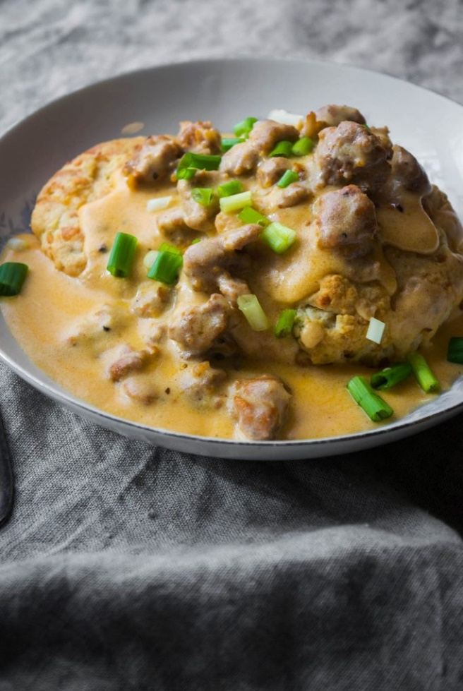

Black Pepper Buttermilk Biscuits

* All Purpose Flour – 12 oz
* Salt – 1 tsp
* Sugar - .6 oz
* Baking Powder - .6 oz
* Black Pepper – 2 tsp
* Cold Unsalted Butter, cubed – 4.25 oz
* Buttermilk, cold – 7.5 oz
* Egg (whisked for egg wash) – 2 ea
* Melted butter, to finish – 2 oz

1. Preheat oven to 425 degrees
2. Sift the dry ingredients together.
3. Cut in the very cold butter, working into marble or pea sized pieces. Do not over blend.
4. Add the milk and stir to gently combine.
5. Turn out the mixture onto a lightly floured surface and knead 3-5 times, forming a mass.
6. Gently shape into a square, with the dough approximately 1- ½ inches high.
7. Cut into 6 equal sized squares.
8. Transfer gently to a parchment lined baking sheet. Brush each biscuit top lightly with the beaten egg.
9. Bake about 8-12 minutes until the bottom has lightly browned and the top begins to show some color.
10. Remove from the oven and brush with melted butter. Keep warm.

Chorizo Gravy

* Butter – 1 oz
* Onions, finely diced – 2 oz
* Chorizo, raw – 8 oz
* Flour – 1 oz
* Milk – 2 cups
* Scallions- 2 ea, sliced for garnish

1. In a medium saucepan, melt butter over medium-low heat. Once butter is melted, add finely diced onions and sweat until they soften.
2. Raise the heat, add in the chorizo sausage, stirring well to cook, breaking the meat up a little as you go, until sausage is fully cooked- about 5 minutes. Pour off excess grease as needed, but keeping some in the pan to make a roux.
3. Add flour and whisk to fully combine flour with butter and chorizo drippings.
4. Slowly whisk in milk and cook on medium heat, stirring occasionally, until thickened- about 5-6 minutes.
5. Add salt and pepper to taste if needed.
6. Serve hot gravy over biscuits and top with chopped scallions!

**Mini Cheesy Grits Souffle (6ea 4oz servings)**

* Grits - 6 oz
* Water - 18 oz
* Milk - 18 oz
* Butter - 3 oz
* Salt - to taste
* Tabasco - ½ tsp
* Cheddar Cheese, grated - 6 oz
* Eggs, Separated - 5
* Sugar -1 1/2tsp

1. Preheat oven to 350 degrees.
2. Combine the grits, water, milk and salt in a heavy saucepan. Bring to a simmer, and cook stirring constantly until they have thicken and softened about 10 minutes.
3. Remove from the heat and stir in the tobacco, 4 oz of cheese. (remaining cheese is for topping0. Then stir in the Egg Yolks.
4. In a separate bowl, whip the egg yolks ad sugar to stiff peaks. Fold the egg whites into the grits mixture.
5. Pour the souffle batter into lightly greased tins. Top with the remaining cheese.
6. Bake at 350 until fully set.

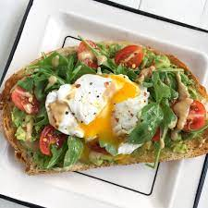

**Ultimate Avocado Toast**

* Water – 1 quart
* Salt – 1 TB
* Vinegar – 1 oz
* Eggs - 6 ea
* Bread Slices - 6 ea
* Cherry or Grape tomatoes, asst colors – 1 cup
* Olive oil – 2 TB
* Basil, chiffonade- 2 TB
* Baby Arugula, torn – 1 cup
* Salt and Cracked Black Pepper to taste
* Avocado, ripe – 3 ea
* Scallions, sliced thin - 2 ea
* Lemon Juice - 1-2 Tb
* Lemon Zest - 1 TB
* Everything Seasoning, as needed

1. In a small pot, heat 2 quarts of water with a pinch of salt and the white vinegar. Bring to a poach at 180 degrees.
2. Lightly toast bread slices and set aside.
3. Cut the tomatoes into quarters. Toss with salt, pepper, olive oil, and basil. Gently Stir in arugula leaves. Keep aside.
4. Slice avocados in half and remove pits. Place the pulp into a bowl.
5. Mash together the avocado, scallions, lemon juice and lemon zest. Lightly season with salt and pepper.
6. Place a generous amount of the Avocado mixture on a slice of toast. Then top with a small portion of the tomato arugula salad.
7. Poach each egg to achieve a fully cooked white with a medium cooked yolk egg (or cooked as desired). Remove with a slotted spoon and place onto paper towel lined plate to dry.
8. Top each toast with a poached egg.
9. Sprinkle lightly with Everything Seasoning and serve.

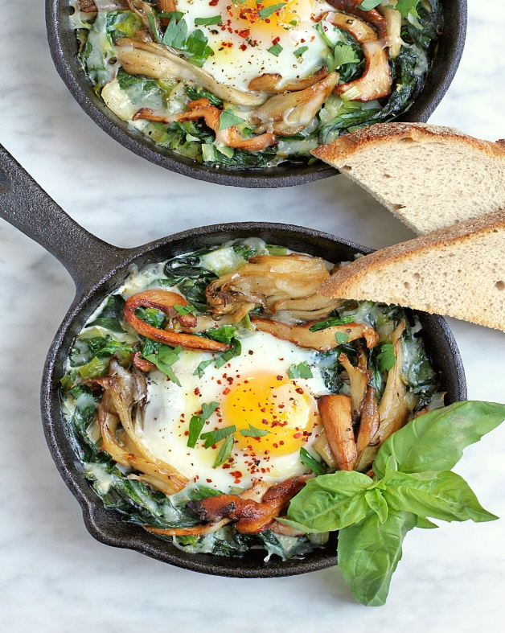**Mushroom and Leek Shirred Eggs with Truffled Mornay Sauce**

Shirred Eggs

* Butter – 1 1/2 oz
* Mushrooms, sliced thin – 3 oz
* Leeks, white part only, julienned - 1/2 cup
* Ham, small dice – 3 oz
* Parsley, minced – 2 TB
* Salt & pepper, to taste
* Butter, melted – 3 oz or as needed
* Eggs -6 ea
* Swiss Cheese, grated – 4 oz

1. Preheat oven to 325 degrees.
2. In a small saute pan, melt butter.
3. Add the mushroom and leeks over medium heat, and sweat, stirring frequently until they are well softened.
4. Add in diced ham to warm through, then remove from heat. Stir in parsley and season to taste.
5. Lightly brush a 2 “half pan with melted butter. Place the mixture into the bottom of pan. (Alternately, these may be baked individually)
6. Top with a raw egg and bake at 325 about 8-10 minutes.
7. Remove from the oven and top with grated Swiss and hot heavy cream. Return to the oven until cheese has melted and egg is cooked as desired.
8. Top with the Truffle Mornay Sauce, a sprinkle of parsley and serve while hot.

Truffled Mornay Sauce Yields approx. 30 oz

* Milk –3 cup
* Onion – 1/4 wedge
* Bay Leaf - 1
* Clove - 1
* Butter – 1.5 oz
* Flour – 1.5 oz
* Parmesan Cheese, grated – 1 oz
* Swiss Cheese, grated – 4 oz
* Heavy Cream -2-3 oz
* Butter- 2 oz
* Salt, White Pepper and Nutmeg – to taste
* Truffle Oil or Truffle Paste - 1 TB

1. Make an “onion pique” by securing the bay leaf to the onion, by piercing through with the clove.
2. Place the onion pique and the milk In a small stainless steel saucepot, and heat to a simmer for 20 minutes.
3. In a separate small stainless steel saucepot, melt butter, adding flour to make a white roux.
4. Slowly add the milk to the roux, whisking vigorously to prevent lumps.
5. Bring the pot to a simmer, stirring frequently, allowing it to simmer for 30 minutes.
6. Strain through a china cap and stir in cheeses to melt.
7. Add in heavy cream to thin, and swirl in butter.
8. Season to taste with salt, white pepper and grated nutmeg.
9. Finish with truffle oil.