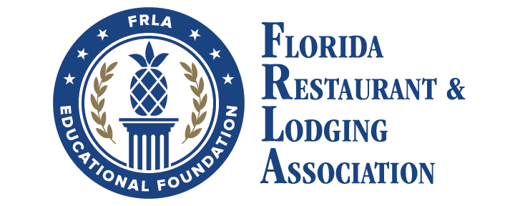

**Curriculums**

* **HTM**
  + Beginning with the 2021-2022 school year, the curriculum changed to one very large textbook. However, instructors may take two years to cover the material if they prefer. According to our fall survey, there were 5,176 students enrolled in 41 HTM programs.
  + At the completion of the textbook the student can pass an exam, along with 100 hours of industry experience, to earn the industry certification which is the Hospitality and Tourism Specialist.

<https://www.ahlei.org/program/hospitality-and-tourism-specialist-credential-program/>

* **CAPE Funding**

Due to legislative rules governing what is an industry certification, the original HTM certification is not on the Master Credentials List or CAPE list. ServSafe and National Registry remain on the list and are the certifications most used by HTM schools. HTS has been submitted for the Master’s Credentials List.

**Opportunities**

* **Foodsafety Training**

There are two industry certifications, tied to manager level foodsafety training, on the CAPE list. ServSafe and National Registry are both owned by the National Restaurant Association but completely different companies. For more information on ServSafe, contact us or go to www.servsafe.com. For more information on National Registry, visit www.nrfsp.com.

* **Mini Grants**

For the 2024 - 2024 school year, $120,000 in mini grant funding will be available for ProStart and HTM schools. Historically, every school that applies receives some level of funding. HTM schools have used mini grant funding for polos, furniture for “lobby area”, coffee bar supplies, signage, Knowledge Matters, etc. The Request For Proposals (RFP) will be distributed to the schools in the August edition of NewsBites. We anticipate reviewing applications in October.

* **Hospitality Industry Internships**

The EF will award Hospitality Industry Internships to ProStart and HTM programs which provide the opportunity for instructors to work 40 hours in a foodservice or lodging establishment. The instructor can take the knowledge learned in the hospitality industry back to the classroom. The instructor receives $600 from the EF to compensate them for their time. The applications for Hospitality Industry Internships will be available in the August edition of NewsBites.

* **HTM Competition**

The HTM Competitions will be held February 13-14, 2025, at the Rosen Plaza in Orlando. The two-day event will include the Hospitality Project, Hotel Operations and Knowledge. Each team of four students must compete in all events. The FRLAEF covers the cost of hotel rooms and most meals.

* **Scholarships**

Each January, the FRLAEF releases a scholarship application for graduating seniors who are planning to pursue a degree in the culinary or hospitality industry. Students are required to complete a simple application, answer one essay question, and provide their high school transcripts. For the fourth year in a row, all eligible students that completed all the requirements received a scholarship. The FRLAEF awarded $90,000 in scholarships for students beginning their college education this fall.