**Menu:**

* Smoked Salmon Roulade
* Caviar, Avocado and Sourcream
* Salty Lapskaus
* Tilslorte bondepiker (Veiled Peasant Girls)

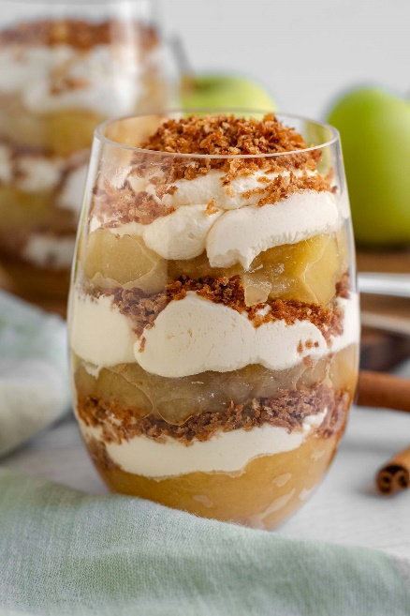

Salty Lapskaus

* 3 lb salted pork but diced
* water or beef stock to cover the meat
* 4 lb Potatoes diced ¾ inch
* 1 lbs Rutabaga diced ¾ inch
* 1 lbs Carrots diced ¾ inch
* 12 oz Sellery root diced ¾ inch
* ½ Leek sliced
* Salt for your taste
* black pepper for your taste

1. C**ut the meat in big dices (3/4 inch)**
2. **Put meat, the** diced potatoes and vegetables **a big pot**, **add water/beef stock until it cover the meat/vegetables and bring to a boil.** Turn down the heat and simmer until everything is soft
3. Taste with salt pepper
4. serve and sprinkle with freshly chopped parsley and serve

Smoked Salmon Roulade

* Gluten
* Seafood
* No thyme

1. Put running water over 5 Vestlands lefse (just some few seconds) and let it rest 5 minutes on a plate covered with plastic.
2. Mix sour cream, garlic, salt, pepper and basil.
3. Cover the Vestlands lefse with a thin layer of sour cream.
4. Put a layer of smoked salmon and arugula on top of the Vestlands lefse.
5. Roll the Vestlands lefse tight as a sausage in plastic wrap and put it in the fridge for up to two days.
6. Remove the plastic wrap and cut the rolls in slices and serve on a plate.

Caviar, Avocado and Sourcream

* A plate of food on a table

  Description automatically generatedSeafood

Make enough for 15 spoons

1. Cut avocado in nice dices/slices.
2. Cut red onion in small dices.
3. Arrange the avocado, caviar, sour cream, red onion   
   and dill on a serving spoon and serve.

# A glass of dessert with apples and whipped creamTilslørte bondepiker (veiled peasant girls)

Applesauce:

* 10 Green peeled and diced (¾ inch) apples.
* ½ cup Sugar
* 1 cup Water

1. In a saucepan, combine the diced apples sugar and water.
2. Bring to a boil then reduce heat and simmer about 10-15 minutes, stirring occasionally. Cook until the apples are soft. Set aside to cool to room temperature.

Breadcrumbs:

* 1/2 cup butter
* 1 cup Sugar
* 2 cup Bread crumb
* 1-2 ts Ground cinnamon (taste)

1. In a skillet, melt the butter over medium-low heat.
2. Add Breadcrumb, cinnamon and 1 cup sugar.   
   Stir frequently until breadcrumbs are crispy and golden brown, about 5-7 minutes. Set aside to cool.
3. Run in a robot Coupe if the pieces get to big

Whipped cream:

* ½ cup Sugar
* 1 qt Heavy cream
* 1 ts Vanilla extract (taste)

1. In a chilled mixing bowl, beat the heavy cream, 1 cup sugar, and vanilla extract together until medium-stiff peaks form. Set aside.

**Now it’s time to put it all together!**

* In individual serving glasses or a larger serving dish, start by adding a layer of the applesauce.
* Follow with a layer of whipped cream on top of the applesauce.
* Sprinkle a layer of caramelized breadcrumbs over the whipped cream.
* Repeat the layers until you filled the glass, finishing with a layer of breadcrumbs on top.