Southeast Asian Cuisine
Appetizer: Fresh Vietnamese spring rolls
Entrée: Thai grilled chicken with grilled vegetables
Entrée: Pan fried snapper with Ginger & Tamarind Sauce
Side: Vegetable and Basil Thai fried rice
Dessert: Coconut Custard and Mango Sticky rice
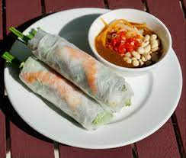 | 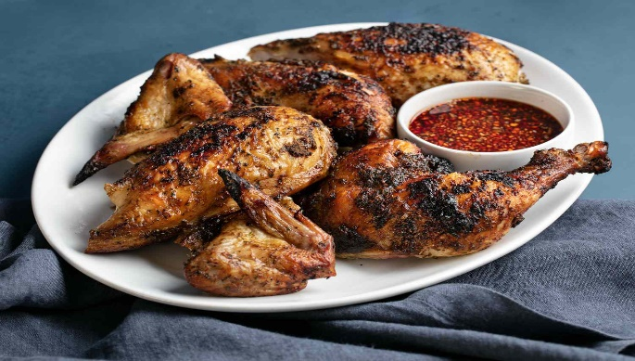

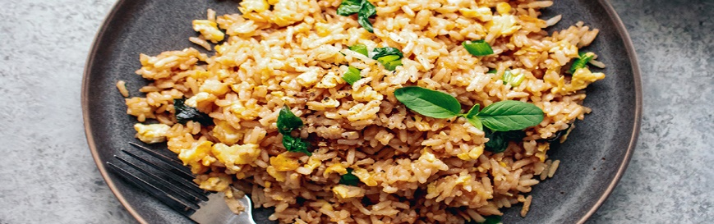 | 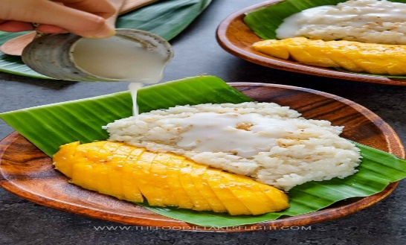

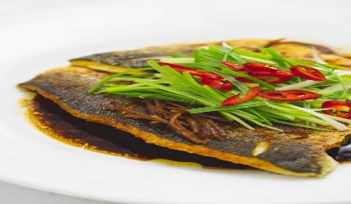

Fresh Vietnamese spring rolls
Grilled sliced pork loin:
Ingredients for marinate. Amounts:
- Fish sauce  - Soy sauce  - Hoisin sauce  - Honey  - Minced lemon grass  - Minced garlic  - Brown sugar  - Lime juice  - Salt and pepper | - 2 tablespoons.  - 2 ounces.  - 3 ounces.  - 2 ounces.  - 1.5 ounces  - .5 ounce  - 2 ounces  - 2 ounces  - TT

This will marinate about 2.5 to 3 lbs. of quarter inch sliced pork loin. Marinated pork loin for 20 to 30 minutes and then grill. Cool down the grilled pork and cut into batonnet size.
Poach shrimp.
- Peeled and deveined shrimp (20-30)  - Water  - Bay leaf  - Lemon grass  - Salt and pepper | - 3 lbs.  - 1 gallon  - 2 each  - 2 stalks, mashed.  - TT

Add all ingredients to the water in a pot without the shrimp. Bring the pot to a boil then bring it down to a simmer. Add the shrimp and cook the shrimp until firm. Shock them in ice cold water then sliced them in half like butterflying them.
Hoisin peanut dipping sauce
- Hoisin sauce  - Orange juice  - Lime juice  - Honey  - Peanut butter  - Chopped peanuts  - Salt and pepper | - 2 cups  - 1 cup  - 1 cup  - Half cup  - Half cup  - ¼ cup  - TT

Add all ingredients to a saucepan except for peanut butter and chopped peanuts. Bring the ingredients in the saucepan to a boil for 5 minutes then whisk in the peanut a little bit at a time until thicken. Adjust with salt and pepper as needed and garnish with chopped peanuts.
Fresh rolls
- Sliced Romain lettuce
- Round rice paper wrappers
- Cut cilantro
- Sliced shrimp
- Batonnet cut grilled porkloin
- Boiled cooled rice noodles
Follow Chef’s demonstration to wrap the fresh Vietnamese spring rolls.
Thai Grilled Chicken legs with Nam Jim Jaew
Marinated for 15 lbs. of chicken legs n thigh.
- White peppercorns, black pepper is fine too. | - 1 TB
- Toasted coriander seeds | - 2 oz.
- Lemongrass, bottom half only, thinly sliced | - 5 oz.
- Garlic, minced | - 2 oz.
- Soy sauce | - 4 oz.
- Fish sauce | - 3 oz.
- Thai black soy sauce or dark soy sauce. | - 3 oz.
- Sugar | - 4 oz.
- Neutral oil | - 3 oz.
- tumeric | - 2 oz.

Nam Jim Jaew
- Tamarind paste, | - 4 oz.
- light brown sugar | - 4 oz.
- water | - 4 oz.
- Fish sauce | - 2 oz.
- Lime juice | - 2 oz.
- Chili flakes, to taste | - TT
- Shallots, finely chopped | - 2 oz.
- Green onion, chopped | - 3 oz.
- Cilantro, chopped | - 2 oz.
- Toasted rice powder. Toast raw white rice grains until lightly brown then grind in spice grinder. | - 3 oz.

Add water to light brown sugar in a saucepan and bring to a boil until sugar melts. Allow it cool to room temperature and add all other ingredients.

Grilled assorted vegetables.
Sliced all vegetables to a ¼ inch thick and add vegetable oil enough to coat the vegetables and season with salt and pepper to taste. Grill and serve.
- Zucchini
- Squash
- Onions
- Red bell peppers
Pan Fried snapper with Ginger & Tamarind sauce
Pan fried snapper
- Snapper with skin on - 4 oz. portions  - Cornstarch to coat  - Salt n pepper to taste | - Coat the snapper with cornstarch and salt n pepper  - Pan fried until crispy and firm

Ginger & Tamarind sauce
- Sliced garlic…2oz.  - Sliced shallots..2 oz.  - Julienned fresh ginger.. 2 oz.  - Soy sauce…3 oz.  - Sugar…3 oz.  - Tamarind paste..3 oz.  - Fish sauce…2 oz.  - Lime juice….2 oz.  - Julienned red bell pepper…8 oz.  - Fresh Thai basil leaves…2 oz.  - Fish stock or chicken stock….8 oz.  - Slurry… as needed | - Sauteed garlic, shallots, & ginger.  - Add soy sauce, fish sauce, sugar, tamarind paste, & lime juice in the pot.  - Once boiled, add slurry to thicken.  - Add bell pepper and basil.  - Serve with the fried snapper.

Coconut custard and Mango sticky rice
- Steamed sticky rice.  - Fresh ¼” sliced Mangos  - Coconut milk  - Sugar  - Eggs  - Egg yolk  - Vanilla extract  - Heavy cream  - salt | - 5 lbs.  - 4 each  - 4 cans/14oz  - 10 oz.  - 8 each  - 8 each  - 2 tablespoons.  - 1 cup  - 1 tsp

1. In a saucepan heat up 5 oz. of sugar with 2 cans of coconut milk and 1 tsp of salt, until sugar melts.
2. Add the steamed sticky rice to hot coconut milk mixture and stir to reserve.
3. In another saucepan, add half of the heavy cream, 3 oz. sugar, vanilla extract, and 1 can of coconut milk, bring it to a simmer.
4. In a mixing bowl, whisk eggs, egg yolks, remaining sugar, 1 can coconut milk, and remaining heavy cream.
5. Temper the egg mixture with the hot coconut milk and cream until it slightly coats a spoon and leave it aside.
6. ins a square pan, layer the sticky rice on it, in about 1 inch thick, then layer half of the mango on it, then another layer of mango, then another layer of mango, and finally add the custard on top of the mango.
7. Bake the square pan covered with aluminum foil in a water bath until the custard sets. It would be about 15 to 20 minutes.
Thai Basil Fried rice
- 10 lbs. of cooked jasmine rice  - 8 oz. of wavy cut carrots  - 8 oz. of julienne onions  - 2 oz. of Thai basil leaves  - 3 oz. fish sauce  - 2 oz. sugar  - Salt and pepper TT  - 6 whole eggs  - 2 cups of vegetable oil  - 1 cup of chopped garlic | Chef will demo

