SOCRATIC SEMINAR

Early in the week I would give my class an assignment (usually it was a study guide for a chapter of whatever book we were reading) and they would complete it in class. At the end of the week, they would use that study guide as their text for the graded discussion that they would have with each other. For a culinary class, I can imagine it working like this:

Day 1 - Class is divided into two groups and given an assignment to write down every step in creating a hotel pan of lasagna for an imaginary event that will be held in three days. I want to see ingredients list, prep procedures, cooking procedures, cooling, storing, reheating, servicing, etc.....

Day 2 - Socratic Seminar Group 1 sits in a circle and talks to each about the process that they came up with yesterday. Each member of the group has a set of tickets (attached picture) with their names on the back. I give them a 15-minute time limit to complete the discussion. As they have their discussion with each other, I walk around the circle listening to them and as they complete one of the tasks on the ticket, I take their ticket from them. The tickets are worth 5-points each (or whatever makes sense for the class), so in order to receive the full 25 points, each student must:

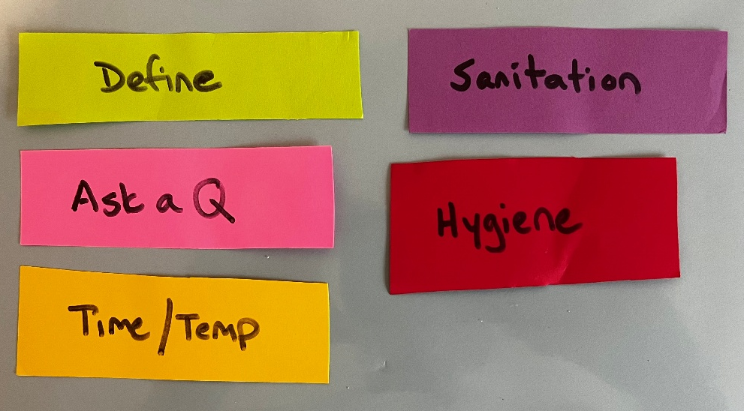
- Define a term (green ticket)
- Ask another student a question about something specific that they said (pink ticket)
- Mention something in the process related to Hygiene ( red ticket)
- Mention something in the process related to Time/Temp (yellow ticket)
- Mention something in the process related to Sanitation (purple ticket)

At the end of the time limit, I have collected the tickets, and I can tally up the points for each student.

The other group is sitting in a larger circle outside of the smaller circle and they are actively listening to the discussion and taking notes. When the time is up, we switch so group 2 has their discussion in the inner circle and group 1 becomes the listeners.

It does take some practice for the kids to get used to the activity, but once they got it down it worked great. They were actively talking to each other and inevitably, they would prod each other to talk when the time was running down so that everyone would get rid of their tickets. It was really cool to see.

