25th Annual ProStart Culinary Team Competitions

FRESH FROM FLORIDA

Waiter’s Relay Competition


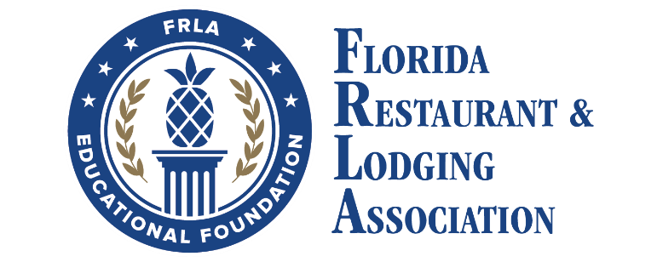

Waiter’s Relay

Competition

Saturday, February 21, 2026

Purpose
Participating teams will demonstrate their ability to set a table with three designated place settings and three napkin folds while racing against the clock.

Eligibility
Students
- Participating students must be enrolled in a Premier or Full ProStart Program using the ProStart® curriculum during the 2025 – 2026 school year.
- Participating students must be juniors or seniors in high school and may only compete a total of two years.
- A student may compete in only one (1) competition.

Teams
- The team must consist of students from the same school or career center. If the students are not from the same school or career center, the team will be disqualified.
- Only one (1) team per school may compete in the Culinary Competition.
- A team will consist of three (3) team members.

SCHEDULES
- Competition schedules will be distributed in advance of the event. All schedules are subject to change without notice, but changes will be communicated with as much advance notice as possible.

GENERAL RULES
- Proper safety techniques must be followed by all team members. No horseplay or unduly hazardous behavior will be allowed or tolerated. The mentors, teachers, chaperones, and families are expected to ensure that the team members comply with all applicable laws, rules, and regulations. Team members shall comply with all other written as well as verbal instructions or warnings provided by FRLA.
- The team will send all required information to the Florida Restaurant & Lodging Association Educational Foundation (FRLAEF) no later than January 23, 2026. (If necessary, you will be able to make changes after you turn in your information.) If all the required information is not received by 5:00 pm on January 23, 2026, the first team on the waiting list will replace your team in the competition.
- If the team experiences a medical emergency competition staff, at their discretion, may stop the timer until the medical situation is resolved. The team will then be given the time remaining to complete the meal.
Uniforms
- Teams must present a uniform appearance throughout the competition.
- Appropriate apparel for front-of-the-house attire (such as apron, white shirt, black pants, and closed toe shoes) or Attire can also include polo shirts or dress shirts, dress pants/skirts and dress shoes. Sponsor logo T-shirts will be acceptable. Jeans are not acceptable. Attire must be school appropriate.
- The uniform examples listed above are examples and not required in their entirety. The emphasis is on team uniformity.

Procedure
- Each team will set a table for three guests with these required place settings: American Place Setting, Russian Place Setting, and French Place Setting. Examples are attached. These examples will be provided to the judges for comparison during the competition. They can also be found at this link: https://frla.org/2026-napkin-folds-place-settings/
- There are three required napkin folds: ENVELOPE, LILY, AND PYRAMID. Control/Click on the link above to watch YouTube tutorials. Or cut and paste the link below into your browser. These examples will be provided to the judges for comparison during judging. Pictures of the napkin folds are attached.
- It is up to the team’s discretion as to which napkin fold is placed with each place setting. The only requirement is that each place setting and each napkin fold be demonstrated.
- Teams will begin the relay at the start/finish line. Stations will be set up throughout the relay with various items needed to set the final table on each station. Past the stations will be a round 8-foot table with three chairs.
- The FRLAEF will provide all items required to complete the relay (i.e. napkins, dishware, flatware, glassware, tablecloths and wrist coil key chain).
- Prior to a team member beginning his/her leg of the competition, he/she must receive the team wrist coil key chain from the previous team member to proceed.
- Teams will not be assessed penalties for how the team members carry any of the items to the table. For example, the team member carrying the glasses to the table does not have to carry them as if he/she were serving guests.
- Judges will be placed throughout the relay to determine if a team member drops any items. If any item is dropped, the team will be given a 10 second penalty for each item dropped.
- After the first round, the top 8 teams will advance to a second round. The top 8 teams will then run the relay again. The teams' scores from the second round will determine the event winners.

Waiter’s Relay
- FIRST LEG
The first team member must take the wrist coil key chain and proceed to the table linen and dish area. The team member must bring a tablecloth and the required dishes to the table they are setting. When the team member arrives at the new table, he/she must put the tablecloth on the table. The tablecloth must cover the entire table top and not touch the ground. The team member must place the dishes on the table according to their designated place setting. The team member will be responsible for putting all the dishes on the table. Once the team member completes the task, he/she must go back to the start/finish line to hand off the wrist coil key chain to the second team member.

- SECOND LEG
The second team member must take the wrist coil key chain and proceed to the silverware and glassware area. The team member must deliver all the necessary silverware and glassware to the table he/she is setting. The team member may make as many trips as necessary to collect all the items. The team member must set the table exactly as the designated place settings require. Once the team member completes the task, he/she must go back to the start/finish line to hand off the wrist coil key chain to the third team member.

- THIRD LEG
The third team member must take the wrist coil key chain and proceed to the napkin area. The team member must pick up three (3) napkins and bring them to the table he/she is setting. The team member must then proceed to fold one of each of the three napkin folds. The three required napkin folds are Envelope, Lily, and Pyramid. The team member may place each napkin at the place setting of his/her choice. Once the team member completes the task, he/she must cross the start/finish line. When the third team member crosses the finish line, the timer will record the time.

Scoring
1. Each team will be timed while completing the Waiter’s Relay Competition.
2. Any penalties will be added to the final time.
3. After the first round, the top eight teams will advance to the second round.
- During the second round, each of the top eight teams will run the relay again.
5. The teams' scores from the second round will determine the event winners.

Penalties
- Incorrectly setting items in the relay (i.e., incorrect placement of knives) during the leg. If a team member fixes the problem later the team still receives one (1) minute.
For example, if one knife is set incorrectly, the team receives 1 minute added to their final score. If more than one knife is set incorrectly, the team still only receives 1 minute added to their final score. The maximum penalty per item type is 1 minute.
- Addition of one (1) minute for dinner plates
- Addition of one (1) minute for bread plates
- Addition of one (1) minute for knives
- Addition of one (1) minute for forks
- Addition of one (1) minute for spoons
- Addition of one (1) minute for glasses
- Addition of one (1) minute for napkins
2. Napkin fold must closely resemble the designated napkin fold. If the judges decide the napkin fold does not resemble the designated napkin fold:
- Addition of one (1) minute per napkin not resembling the designated napkin fold. The maximum penalty is three (3) minutes. That is a one-minute penalty per incorrect napkin fold.
- If any item is dropped, there will be given a 10 second penalty for each item dropped.
- If the tablecloth does not cover the entire table top and/or parts of the tablecloth touch the ground, a 10 second penalty will be assessed.
- Inappropriate attire (i.e., jeans) and/or no uniformity among team members:
- Addition of one (1) minute.

Disqualification
- If team is not present at their appointed time to compete, the team may be disqualified.
- Team does not return all required paperwork by January 23, 2026 deadline.
- The team is comprised of students from different schools or career centers.
- Teams and all associated competitors must be eligible to compete, as defined by the eligibility terms above. Teams found to be ineligible will be disqualified. Additionally, any individual students found to be ineligible will result in complete team disqualification.
- Misconduct including, but not limited to, any nonprescription drug use, alcohol use, unsportsmanlike conduct, or any activity that is illegal under federal, state, or local laws, at the event, during competition, during unsupervised free time, during supervised competition social activities or in activities or locations related to the event. Should such alleged misconduct come to the FRLAEF’s attention, the matter will be investigated as the FRLAEF deems appropriate. Any decision as to appropriate action due to misconduct, up to and including disqualification, is at the sole discretion of the NRAEF and is final.
- Teams must participate in each event segment in the competition, or they will be disqualified. Failure to compete in any segment will result in disqualification.
- By entering the contest, the student, and the team he/she represents accept this requirement as well as all other conditions of the Florida ProStart Culinary Team Competitions.

In case of a tie
- The teams will participate in a “finals” relay race. In the event of a tie, all the above rules will apply to this tie breaker.

Awards
1. The teams that finish in the top five will receive medals from the FRLAEF.
2. Various colleges may also award scholarships.

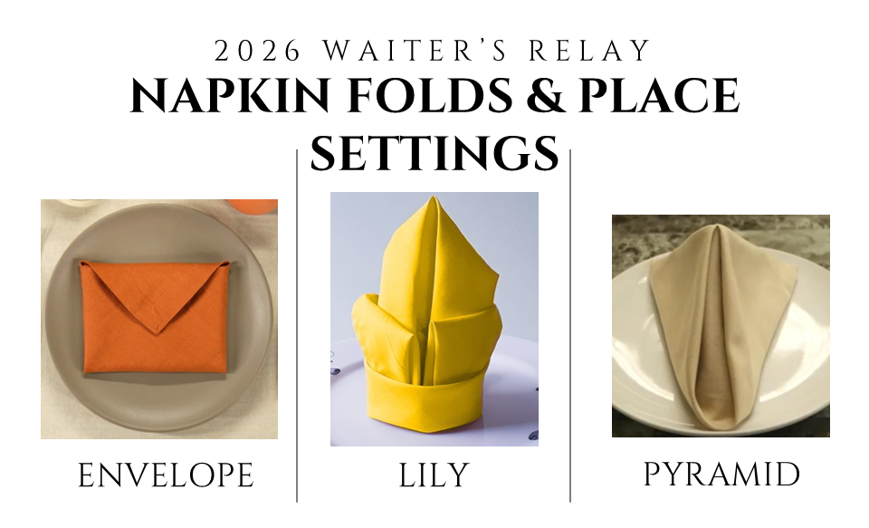
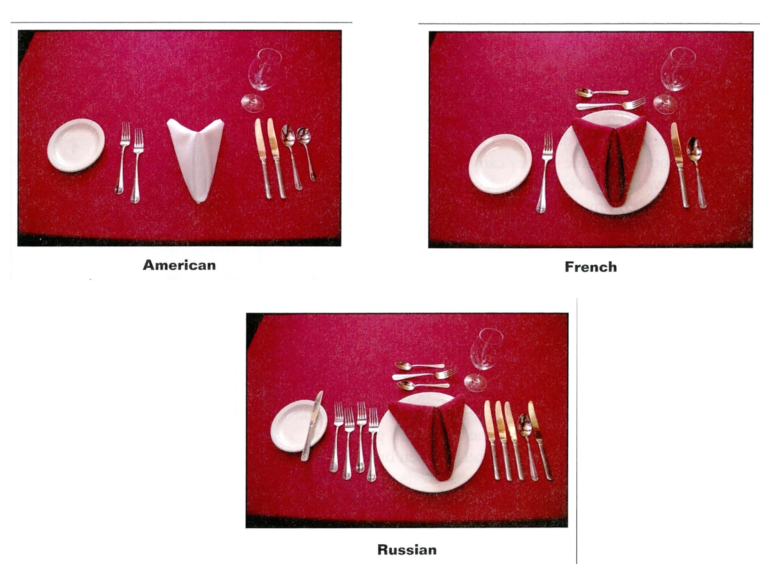

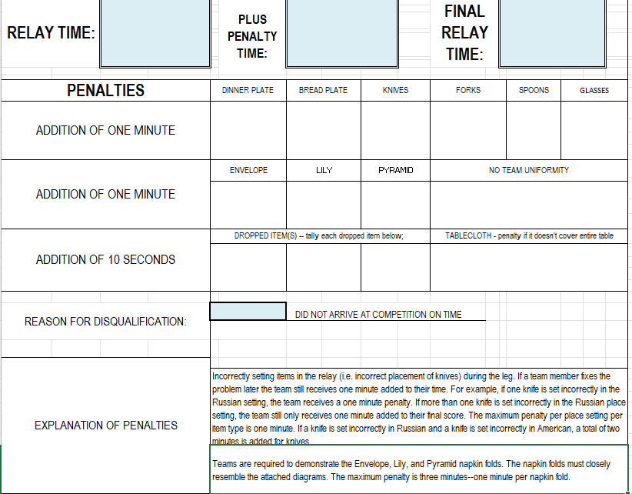
Sample Score Sheet

